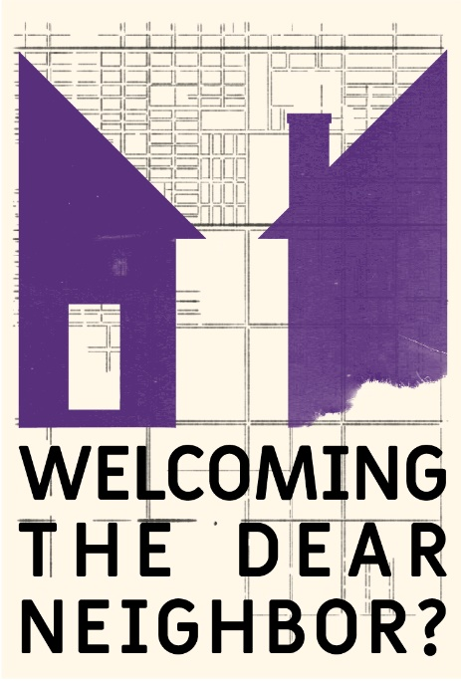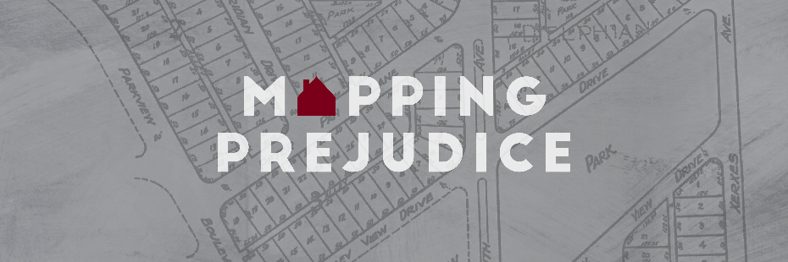***Ramsey County / City of St. Paul &***

***Mapping Prejudice***

***Town Hall***

On April 8, 2021 Ramsey County, City of St. Paul, Mapping Prejudice, and Welcoming the Dear Neighbor? came together to host a Town Hall. Mapping Prejudice provided a sneak peek of the map of racial covenants in Ramsey County. Welcoming the Dear Neighbor? shared stories from the archives. Ramsey County and the City of St. Paul presented their current work to address housing inequality. Hundreds of community members came to learn and had many excellent questions that we did not have time to answer during the event. Staff and faculty from Mapping Prejudice, Welcoming the Dear Neighbor?, and the Ramsey County Community and Economic Development board worked to answer as many questions as possible. Please note that we are unable to answer all questions at this time.

*Q: Is the plan to take this geographic data project national?*

A: Yes! We are looking for collaborators in other parts of the country. Mapping Prejudice wants to work with communities that would like to mobilize volunteers to generate this data. The process is as important as the product. This community engagement creates the meaning and the power around this work.

*Q: What patterns did you find across cities and regions?*

A: Covenants are attached to parcels that were platted between 1910 and 1960. In Hennepin County that means that covenants are arrayed in a pattern that resembles a donut around the center of Minneapolis, which was laid out before developers embraced the use of racial restrictions. Covenants are not necessarily found in some of the most exclusive neighborhoods, as some of them were developed before or after this chronological window. Areas with concentrations of covenants are the whitest parts of Minneapolis today. We expect these same patterns to hold up in Ramsey County.

*Q: What can the historians share about the patterns seen [in Como Park]?*

A: We don't have enough information to say much about patterns in Como Park beyond the fact that there were covenants in the neighborhood. Once the map is complete, this is a neighborhood we are interested in learning more about.

*Q: When will the Ramsey Co. map be available for people to interact with?*

A: By the end of the summer. The map will not be completely finished. But we want community members to see a version of the map as soon as we have something to share.

*Q: How to look up additional information on the history of properties (that show racial covenants)?*

A: This guide provides a primer on researching property in St. Paul and Ramsey County: <https://sppl.org/house-history/>. The folks at the Ramsey County Historical Society can provide expert assistance in this regard: <https://www.rchs.com/research/research-center/>. The best place to start research about a property in Hennepin County is at the Minneapolis Central Library, which has a rich set of resources and expert staff: https://www.hclib.org/programs/genealogy-local-history/researching-homes

*Q: Please send a link where we can go to discharge a covenant in St. Paul*

A: The Minnesota state legislature passed a law that made it possible for property owners anywhere in the state to discharge covenants. The Just Deeds Project formed to help people navigate this process, which can be confusing. For more information, please go to the Just Deeds website: <https://justdeeds.org/>

*Q: How can this information be presented to students? Are there student friendly resources or access to the project? Is there a partnership with SPPS to incorporate this into the district’s plans for culturally relevant instruction? How can we use this information to help our students advocate for themselves and become active stakeholders in their community and righting this systemic issue?*

A: Two St. Kate’s faculty, Dr. Rachel Neiwert and Dr. Kristine West, will be doing work over the next three years to continue conversations with teachers in school districts around the metro area about how to integrate this work into their classrooms. Mapping Prejudice has also created curriculum guides that teachers can use to create lessons: <https://mappingprejudice.umn.edu/resources/index.html#educators>

*Q: Do you have advice for when we come across people who haven't heard this information, don't believe it or are deeply resistant to change?*

A: Ask those people to read these property records for themselves. The text of the covenants is unambiguous. The map also provides a clear visualization of how much land was covered by these restrictions. Some people like to think that this history is irrelevant since covenants and redlining are illegal. But the uncomfortable truth is that we have intolerable racial disparities today. We need to understand where they came from and how they were constructed. That’s the first step.

This approach starts with the premise that people see inequality as a problem. It probably will not reach the people who feel frightened about what they might lose if other people gain access to resources and power. To those people it’s important to explain that it’s not a zero sum game. We all benefit if everyone is thriving.

*Q: How much wealth was created for those who benefited from racial covenants?*

A: Scholars and activists have worked for decades to calculate the sum total of what has been called the “color tax” in real estate or what sociologist Thomas Shapiro calls the hidden cost of being African-American. Research in Chicago has shown that at least $3 billion was extracted from Black communities in the city through real estate transactions that were often racially exploitative. For more details read here: https://www.chicagobusiness.com/equity/toll-racism-chicagos-real-estate-market

Here in the Twin Cities, our team worked with economists to determine how much wealth was gained through these restrictions. Aradhya Sood and Will Speagle used Mapping Prejudice data to calculate that houses in Minneapolis that had covenants are worth 15 percent more than identical houses that did not have covenants. This is true more than 50 years after the passage of the Fair Housing Act. The white families who owned those properties with racial restrictions have benefitted from those higher values, which they have been able to pass on to their children and grandchildren. Read more here: <https://ssrn.com/abstract=3468520>

*Q: Are there current day practices comparable to racial housing covenants?*

A: We get this question a lot. Once racial covenants were made illegal, new practices were developed to keep racial segregation in place. A team of public policy graduate students at the University of Minnesota developed this primer to illuminate the connections between these past and present practices: <https://mappingprejudice.umn.edu/images/Awareness_to_Action_Mapping_Prejudice.pdf>

*Q: Were any covenanted homes affected by the construction of 94 via eminent domain? Are those deeds even available now that the homes and property parcels are gone?*

A: Houses adjacent to the Rondo neighborhood were restricted with covenants. This was not uncommon in areas adjacent to racially-mixed neighborhoods, where property owners often tried to use covenants to maintain the borders of white neighborhoods. Covenants stay in the property records, even in cases where the parcels are redeveloped in massive projects like freeways.

*Q: Has St. Paul or Ramsey County leadership talked about specific reparations measures?*

A: Ramsey County is exploring options to address historic redlining through a housing levy, ideally in conjunction with community partners. This effort is described in the County’s [Economic Inclusion Plan](https://www.ramseycounty.us/sites/default/files/Departments/Community%20%26%20Economic%20Development/Ramsey%20Final%20Report_Pages%2016mar21.pdf) (see recommended actions on page 30).

*Q: Home ownership requires a strong connection to banking. But many people of color do not use banks. How then can they get loans to buy starter homes?*

A: Ramsey County currently offers [assistance](https://www.ramseycounty.us/residents/property-home/home-buyer-home-owner-programs/home-buyer-assistance) to first-time home buyers with low to moderate incomes who are purchasing homes in suburban Ramsey County. Eligible buyers can qualify for up to $15,000 with zero percent interest.

*Q: What more work is there to be done? How can we help continue this work? How can advocates push for policies that dismantle the racist housing patterns established by the legacies of redlining?*

A: There are lots of ways that community members can help. Residents can advocate on behalf of just housing policy decisions at their neighborhood level and with their local elected officials. Show up at meetings and public hearings, comment on policies as they are developed. Local activism is important. Advocate for voices that aren't part of the debate but who are impacted by decisions.

New deeds will be coming to the Mapping Prejudice website in June 2021. Please continue to help by engaging in the deed transcription work on your own or join a weekly deed transcription session.

*Q: How can our affordable housing programs be aligned with building generational wealth? It seems that our current focus on rent-based affordable housing continues the legacies of these racial covenants.*

A: Currently so many households are cost-burdened because of the lack of housing options at all levels of income. Strategies that promote housing development at all income levels allow people to have greater housing options in the future, resulting in more disposable income at the end of each month and the opportunity to build household wealth.

*Q: How do you suggest we tackle this systemic issue of housing when it is at an all time high and also there is very low inventory in the real estate market. Do you have any suggestions or things in the works?*

A: The current housing crisis has been years in the making. Local governments, including [Ramsey County](https://www.ramseycounty.us/sites/default/files/Departments/Community%20%26%20Economic%20Development/Ramsey%20Final%20Report_Pages%2016mar21.pdf) and the city of Saint Paul are both working to ensure an ample supply of safe, high-quality housing for residents at all income levels, with special focus on low-income residents. The federal government is also prioritizing additional resources for affordable housing. However, the reality is that needs continue to outpace limited resources, so it will require a sustained effort.

*Q: Given the stated goals for Ramsey County, How does the new development planned for downtown St. Paul river corridor align with these goals?*

A: Information about the RiversEdge project can be found on the Ramsey County [website](https://www.ramseycounty.us/your-government/projects-initiatives/economic-development-initiatives/riversedge).

*Q: What's in the tenant protections ordinance that addresses fair access?*

A: Information about St. Paul’s ordinance is found here: <https://www.stpaul.gov/departments/financial-empowerment/stable-accessible-fair-equitable-safe-housing>

*Q: I'm a white, (recent) first time homeowner in Rondo and I'm really interested in the Reconnect Rondo project. I know they've brought the proposal to the city but I'm curious about the status of that project and what I can do to support it.*

A: Information about the Reconnect Rondo project is found [here.](https://reconnectrondo.com/)

*Q: Are* ***ALL******covenants illegal****? In neighborhoods that have been and continue to be targets of home* ***flippers*** *there is understanding that homesellers can include a covenant to* ***prevent teardown and construction*** *of new "starter castles."*

A: There are many kinds of legal covenants (environmental, height limits, use of property). Racial covenants are illegal and unenforceable today.